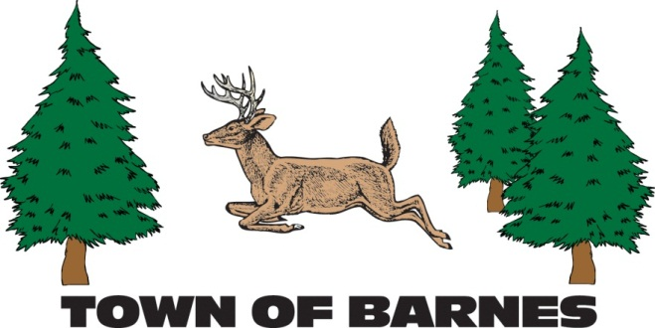
ANNUAL TOWN MEETING
Tuesday, April 21st, 2015
7:00pm at the Barnes Town Hall
3360 County Highway N, Barnes, WI

AGENDA
- STATE OF THE TOWN REPORTS+
- Spring Election Results
- Discussion of Audit & Treasurer’s Report
- Annual Report from the Chair
- Annual Highway Department Report
- Annual Ambulance and Fire Departments Report
- Annual Constable Report
- TOWNSPEOPLE RESOLUTIONS, if any.

Brenda Bakke, Town of Barnes Clerk-Treasurer
Email: clerk@barnes-wi.com Ph: 715-795-2782

